Create a simple cloud software application for Car Booking Reservation System using any Cloud Service Provider to demonstrate SaaS include the necessary fields such as search for cabs, from, to, rental , out station, Package type, hours/Days etc.

Step1: Enter Login Details for Cab Booking Services.

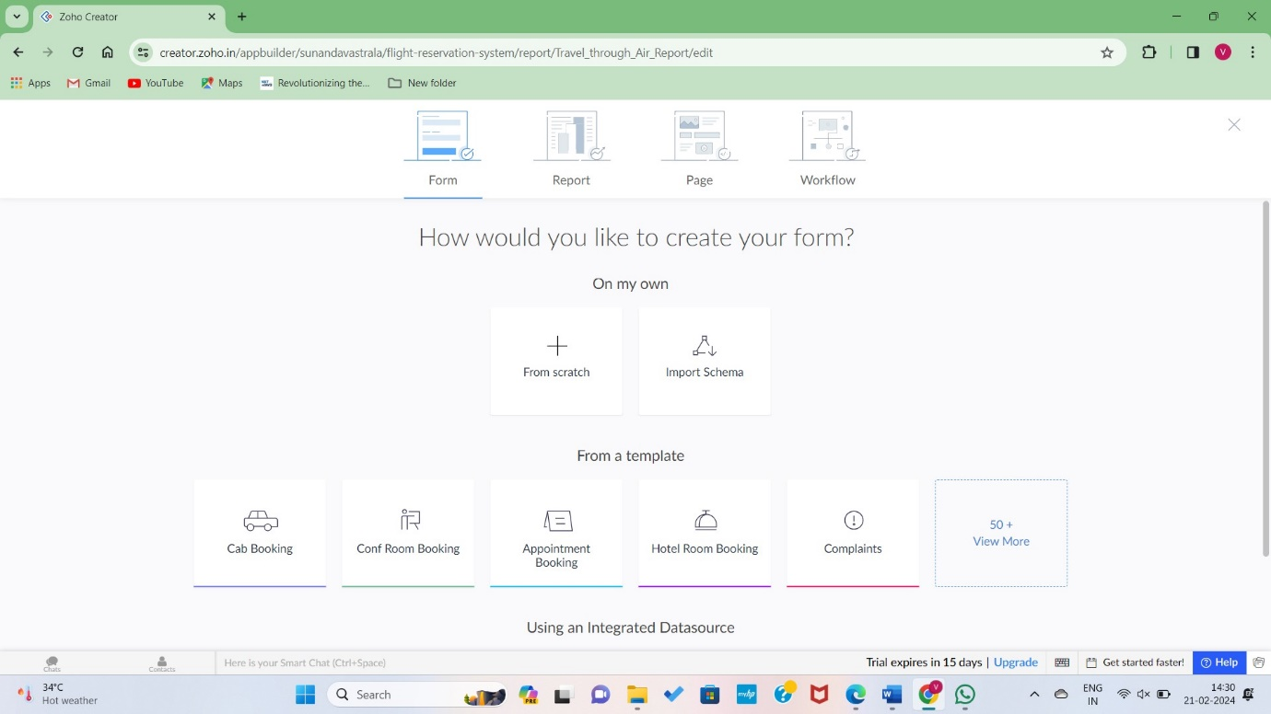

Step2:Entering Details from Scratch.

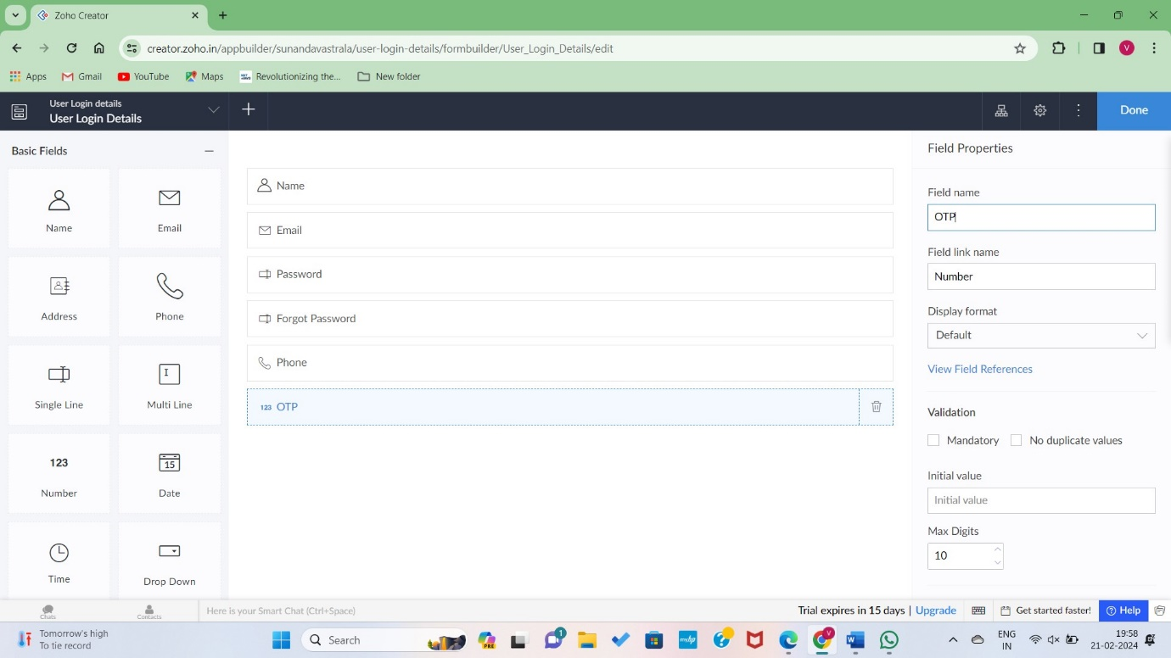

Step3: Filling the necessary details for cab hiring.

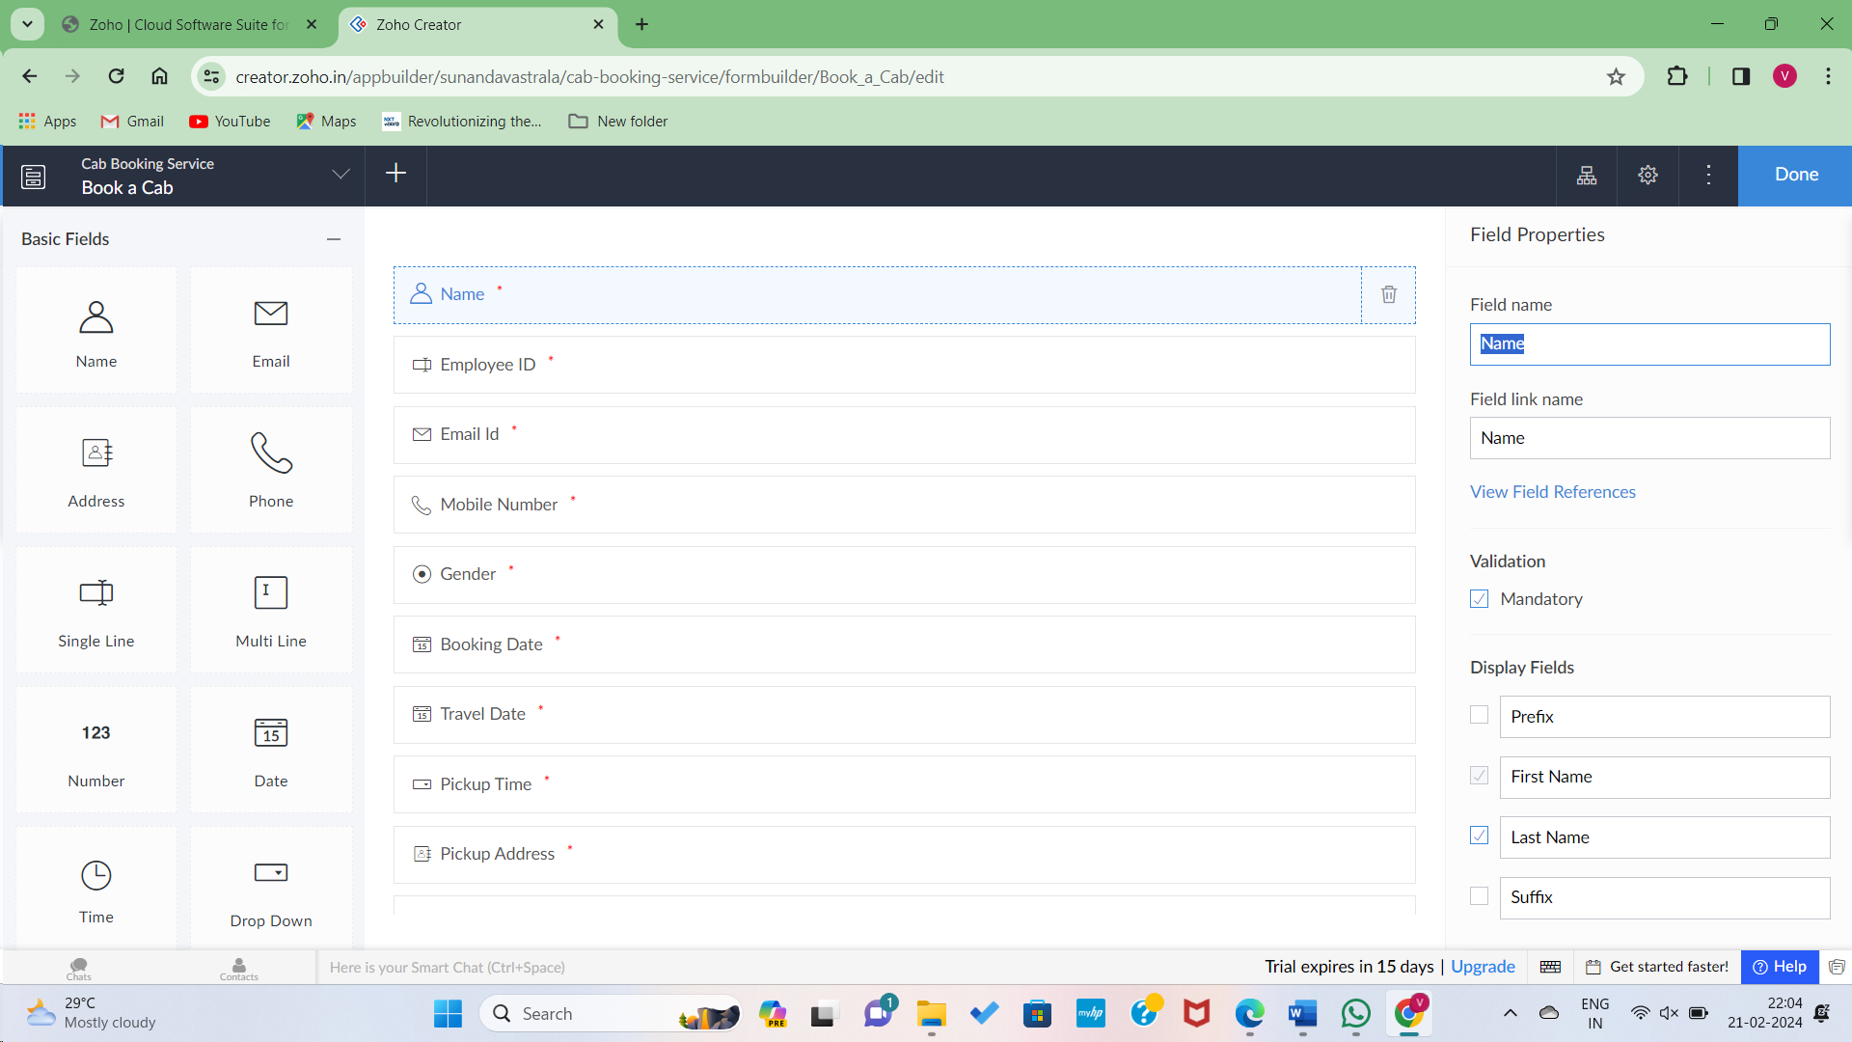

Step4: Adding the data to the webpage.

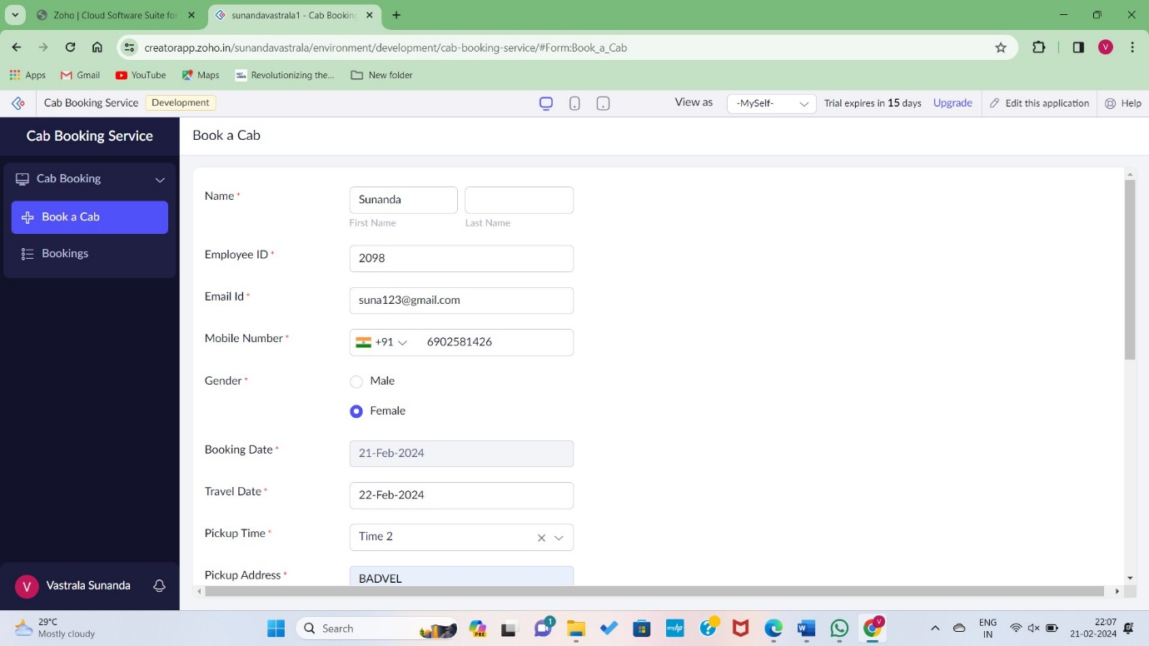

Step5: Data Succesfully Added.

